Meeting called to order: 7:04pm
Members Present: Chairman Serotta, Barry Sloan, Steve Denes, Carl D’Antonio, Dot Wierzbicki, Jackie Elfers
Absent: Bob Conklin
Also Present: Dave Donovan Attorney, Alexa Burchianti Secretary, Al Fusco Engineer
A motion was made to adopt the minutes from March 1, 2017. Motion made by Dot. Second by Jackie. Motion carried 6-0.
Next meeting of the Planning Board is scheduled for May 3, 2017. April 19, 2017 meeting is cancelled.
Hills of Chester-90 Day Extension
Looking to start in 2018. Motion made to grant 90 day extension by Carl. Second by Dot. Motion carried 6-0.
Camp Monroe-90 Day Extension
Needs more time to get the conditions finished. Needs to get the deeds done. And are working with NJ trail conference. Motion made to grant 90 extension. Motion made by Barry. Second by Steve. Motion carried 6-0.
Castle Workshop-Public Hearing Continued
Originally proposed 4800sq ft. building has been redesigned and made smaller. Due to the fill compensation code 52-14 (B)(3) New Rendering and site plan & Elevation certificate was submitted.
Reducing the flood plain area, back of building will be on 4 piers 4x3 approximately 1 foot thick.
They have approximately 90 yards of material credit when the other cottages were removed.
New building is approximately 3150 square feet.
Color scheme to match the main building and have it blend in like the miniature golf. No shadow parking is being eliminated just reconfigured and is all done by an attendant for special occasions.
They have quantity of the trees and landscaping on the plan not the height. Several healthy pine trees are going to be relocated.
Where the “C” is on the rendering would say “maintenance shop” or “workshop” under it.
Tonight is a continuation of the public hearing from last month meeting March 1, 2016 as stated at the last meeting let the record reflect that the mailings and the legal notices were sent out and published. No new ones were sent out not required. Public Hearing is now re-opened.
Anyone want to speak for or against the application come forward.
Leslie Smith: Nice job on the flood plain work. My question is about the zoning. This is in the LB zone that allows the outdoor recreation. When Brian was talking to Vince Finizia at the ZBA they had a discussion about amusement park, not an amusement park, and Brian stated that his……Don: Not to cut you off, but you are one public hearing premature. This is only about the workshop. The zipline is the next one. Leslie: Oh, can I ask a question then about the letter that Mark Edsall sent saying that about the SEQRA review. What’s the difference between a coordinated and uncoordinated review?
Dave: There are 3 types of actions of SEQRA there is a Type 2 which is not subject to any SEQRA review, Unlisted Action and a Type 1 action. Type 1 action is more likely to require the preparation of environmental impact statement and there are certain thresholds that are listed in the SEQRA regulations (that I don’t have with me tonight) suffice to say that this project even combined would not meet any of those thresholds to require a Type 1 action. In a Type 1 action you have to do a coordinated review it’s required. A coordinated review is any involved agencies, defines and agencies that has any discretionary permit approval over any aspect of the project has to be given the opportunity to assert their right to be lead agency. No approval or permit can be given until lead agency finishes the SEQRA process by either declaring a Negative Declaration or issuing a Positive Declaration going through the environmental impact statement process. In an Unlisted Action you can do uncoordinated review which is that each agency that is involved does their own SEQRA review and issues their own SEQRA Negative Declaration and approval. What is happening in relative to the aspects of this project except for the zipline (because that is in both municipalities) the billboard that’s in the town and the workshop that’s in the town is an uncoordinated review. It means the town of Chester planning board operates on their own with their own SEQRA review and issues there approvals.
Leslie: So the Town is doing the SEQRA review on the workshop and the Billboard. And the Village is doing what is over on their side and the zipline.
Dave: Correct, the Town of Chester is an involved agency on the zipline but this board cannot issue any approvals until the Village of Chester Planning Board closes out there SEQRA review of the zipline.
Leslie: Then you have to do a coordinated review on the zipline? Dave: That’s on going. That’s what is going on now. Chairman Serotta: The Village has declared lead agency, we agreed to that and the County agreed to that. They are the lead agency for the zipline.
Clifton Patrick: If you could go to the rendering, on the front elevation to the right of the second window there is something there I was curious to what it was. Brian: that’s interior space.
Ted Talmadge: Site Plan – What I want to know is what is the distance between this building and my property? That needs to be marked on the plan.
Brian: It’s about 30-31ft
Al: That needs to be on the plan. My letter of March 27th states that it needs to be on the plan
Ted: I don’t want to see a bulldozer come in and al of a sudden you are 15ft away.
Jim: That’s not going to happen we would be in violation Ted and then we would need a variance and I don’t think we want that.
Ted: Alright. What about my buffer zone? I don’t see that. Are you leaving that area from where the quick way is all the way down to the cabin there that you are taking down, that whole brushy hillside are you disturbing any of that area? Jim: We have a disturbance line on here as you can see. This is where we are going to try and disturb as minimal as we can (pointing out on the site plan) We are going to be taking down this dwelling (last cabin) so we are going to be getting a little closer to your line and around it. At the building we’re going to try and clear just about 10ft. So what is this board going to give me for a buffer zone? To protect my rights!! Usually Agricultural gets a buffer zone, it may not be in your code but all other towns are doing that for farming people. Basically there’s nothing I could see from that building down to the end of my property. I don’t see anything.
Brian: we can put some pine trees along the property line there if you like, in the area that we are disturbing. Ted: How many feet am I getting here? 20ft? Am I allowed 20ft or more? A lot of towns give 50ft buffer. This property is changing the area and the use here. I’m not changing the use on my side of the fence. Jim: you are getting 30ft. Ted: All the way down? Jim: All the way down. It’s 30ft. Ted: But you are going take the trees that are up by the billboard. You are showing the dotted line that area is going to be cut back. Jim: We are doing some slight grading there we are not getting near your property. Ted: So what is the grading up on the hill there how far is that? Jim: That looks to be about 8ft. Ted: 18ft? Jim: the contour line shows about 13ft over but obviously with construction to get a machine in there this looks about 8ft. The actual disturbance is about 13-15ft away from the property line. Ted: so you are going to replace that with trees and stuff then? Jim: Not on the hill there no. Ted: that’s going to be a bare area then. Jim: This will be seeded (pointed on site plan) purposely didn’t want to put any trees anywhere in there because of your Billboard.
Ted: What about from where the cabin is to the end of the parking lot? Am I getting my 20ft or 30ft of buffer there? Jim: There will be nothing there. Ted: Usually when doing a site plan the board makes people put trees in a buffer zone. Why am I not being given that too?
Barry: What zone is this? Chairman Serotta: LB Barry: In LB district you have a minimum width of 50ft. according to 98-19 B. side yard or rear yard adjacent to residential district. Dave: So Mr. Talmadge is that the LB or is that a different zone? What zoning district? do you know?
Ted: I am Agricultural!! Dave: It matters what zoning district you are in. Barry is reading the same thing that I was reading which is 98-19 B which does regulate side yards in an LB district adjacent to residential district. It doesn’t matter what the USE of your property is it matters what zoning district you are in.
Don pulled up website.
Don: Ted, I took a ride over there, are you ever going to contemplate on cutting the 40ft trees. You have a string of 40ft trees that are 100 years old completely buffering. Those trees are at least 30ft tall at least! You talk about a buffer, first of all there is a stream running right along the back of there, the stream is has to be 10, 15, 20 feet wide. You got Black Meadow creek turns and runs off the back end, so you got a buffer there. Ted: Those trees were put in back in the early 70’s. Chairman: Are you going cut those? Do you have intention of cutting them? Ted: Yeah, I could, Yeah.
Barry: can’t tell if it’s LB to LB. Chairman: the farm house across the street is in Ar3 or LB, Jim you are going to have to check. We may have to send him back for a variance. Barry: You got a minimum width of 50ft, of which the first 25ft nearest to residential district shall be planted with screening or evergreens. Ted: That’s all I’m looking for That’s all.
Chairman: Sometimes, if the board chooses to do that but sometimes it makes no sense.
Dave: Let’s figure out what zoning district it is.
Chairman: (pulled up website) here is the string of 30-40ft trees, black meadow creek. (all pointing out on the website that Chairman is pointing out the location of where everything is and proposed to be) and also showing where there is abandoned farm equipment.
Ted: That may not be there for very long. Chairman: I’m just saying, I don’t know the sense the board requiring evergreen trees when you have 30-40ft trees here. This is a giant screened in area already. I’m not sure you would ever farm right off to the back right to the creek you would have to stay a certain distance away from there anyway. Ted: I could farm right up to the fence line, I could put the cows back there like they were years ago if I wanted. The fences are all there they are falling down a little bit but I can put cows there. Don: I’m not arguing that I’m just saying the point of putting a buffer in when there are 30-40ft trees. Ted: How do you know that tomorrow morning I don’t get a bug up my rear and cut them off.
Dave: I think the answer is this, if it’s adjacent to a residential district you got to comply with the code and if it’s not then the code doesn’t apply.
Don pulled up the map on the projector screen. It was determined that up until Black Meadow Creek is LB and immediately after is AR3. Dave: So the answer to the question about 98-19B that it does NOT apply because it is not adjacent to a residential district. It doesn’t mean that the Planning Board doesn’t have the right impose some kind of buffer if they so inclined.
Ted: So on the Site Plan again, from the building corner down to the end of the property line those parking things. They are going to be allowed to park right up against the fence? There’s no buffer zone at all? Jim: Not for this overflow parking area. We honestly don’t know if we are ever going to use it. Ted: Is this going to be seeded? This isn’t going to wash into the stream? Jim: No, we are not going to change it a bit Brian at one time put a ditch by the rock wall. Brian: a swale is there with rock. Ted: You know what happened? The pond overflowed, and went right down in front of those cabins and it cut into me and took the dirt and everything with it from your property. And you left it there you didn’t retrieve it. And I had a lot of dirt down the stream which we cleaned out last fall. I’m a little unhappy about spending money to do that to. Brian: My pond gets full of sill also where in the other area as you know. Ted: I know that, that was my ancestor’s property. Brian: All down the stream as things go down, anytime the water slows down or overflows …. Ted: You can find a bunch of gravel down there it’s not just sill. Anyway I would still like a berm and some trees there.

Chairman: Ok anyone want to speak for or against the application?
Let the record reflect no one spoke else spoke for or against the application.
Poll board whether to close the hearing.
Motion made to close the public hearing. Motion made by Dot. Second by Jackie. Motion carried 6-0
Al Fusco Letter:
Poll board for Dave to draw up resolution. Board agreed for Dave to draw up resolution for next month’s meeting. May 3, 2017
Castle Zipline-Public Hearing
Jim Dillin for the Castle. Joint application with the Village. Take off and landing is in the Village. The only structure in the Town is the “pole”.
Granted a variance from the ZBA. Can’t build anything higher than 130ft.
Village of Chester is lead agency. It has gone to NYS DOT, Village Planning, County Planning for comments.
Public Hearing is scheduled in the Village for April 25, 2017.
Mike Mier presented the safety procedures and evacuations. Showed the manufacturers evacuation procedures explaining the 4 ways to get someone down safely. One of the concerns was the involvement of a 3rd party such as the fire department. The ride manufacturer does not require any intervention by any outside party. The Castle Fun Center is solely capable to handle any situation that arises with the ride. (all evacuation procedures was explained in detail) if there is a power outage etc. Mike also showed the environmental restrictions.
Barry wanted to see the DOT letter the Village received. Rick will send it over. Rick stated that a very short letter was submitted from DOT.
Al Fusco Letter:

Al Fusco stated he thought maybe the fire department should be referred to, however this was before he realized the system is self-contained. Show the variance on the plan. And where the pole is going to be in relationship to the workshop.
OCDP Response:
Let the record reflect legal notice was posted in the Times Herald Record and all the certified mailings went out. Public Hearing open.
Vin Finizia: Would like to ask the gentleman who talked about the safety, who’s going to inspect it? Other than the Castle. Separate engineer? Mike: The manufacturer has specifically laid out different inspections that take place. The majority of the functions are done by the Castle as the other rides. Then NY State has to inspect those rides as well. Vin: Ok Thank you.
Leslie Smith: It’s in the LB Zone and outdoor recreation is permitted. At one of the zoning board meetings, Vince and Brian were having a discussion about amusement parks, not amusement parks. They were there for the height variance. And Brian basically agreed that his operation in the village could and did fit the description of an amusement park. Since amusement parks are prohibited in all districts. The question remains if this is an amusement ride or not. I have no objection to the zipline really. But if it’s approved and it’s a new use on the property and it’s a ride who’s to say the next application won’t be for other rides on the event grounds property.
Clif Patrick: Didn’t see any notes on the plans for decorative lighting.
Jim: The ride itself has lights on it on the chair. It’s built in and it’s adjustable. They are solid not flashing. You can turn them up and down. The pole has a string of lights. There is no other lighting. No up lighting on the pole.
Clif Patrick: Agree with Leslie, need to define amusement park and outdoor rec. feels lights will be a distraction.
Ted Talmadge: Ask to pull up plan with the pole. The “triangle” on the plan. Talked earlier that there was 30ft from him that they weren’t going to disturb. That anchor shows on plan less than half the distance. I don’t want the anchor there. I want it pulled back more. You are on my buffer zone area. I ask the board not to have that in my buffer zone area.
Jim: What you see are the design and the cables. Ted: I don’t care what you do on your property I don’t want the ground disturbed in the buffer zone.
Jim: The guide wires can be adjustable. And obviously telephone poles and guide wires can be put in, in setbacks. We are going to try and stay away from it. If you look at the plan the disturbance line there, they will try to get, it’s not designed yet, but if that’s one of your concerns we will certainly take it into consideration.
Ted: I’m concerned about the lighting, I’ll see it way over my trees it’s going to be lit up.
Leslie: Didn’t notice any hours of operation on site plan. The August 2011 plan which was last plan approved for this parcel were 9am-10pm. With all amplified music to be off by 10pm. I don’t see anything like that on these plans.
Mike: There will not be any amplified music from the ride after 10pm. Leslie: I didn’t expect that but usually on a site plan there are hours of operation and I just wondered if the same notes were going to be on it with the hours of operation. Jim: We have an exclusive narrative that we are going to be amending and expanding with the village and will make a copy for the Town. It will have to be the same hours as the castle.
Amanda Dana from the Economic Govern Office for Orange County, Director of business retention expansion for the County. Have had the pleasure of working with the organization for many years we have seen them grow. One thing I can say on behalf of the economic government office is that this company has a diverse plan for our region. It has been an icon for children entertainment as well as older children’s entertainment. As you know there are rumors of Legoland coming in up the street and this compliments this project completely. Not saying this has a bearing on it’s approval or not. This family and this organization has done so much to try and keep up and provide that entertainment for our County, our Region, our Village an Town. I would also like to mention they are also a major employer for the County and we hope they will still continue to be that major employer. They had other choices to be other places and they chose to stay here. In this State, this largely taxed and regulated. We strongly support this project and would like to go on record saying that.
Barry: I want to make a comment, throughout the whole presentation and the last month or so and the public hearing, no one has brought up the fact that this is parallel with route 17. That’s why I asked if you got the letter from the state. I want to see what state DOT says. I’m not talking about the safety issue of the ride itself, I’m talking about the safety issue along 17. Chairman: I think you should go to the public hearing on the 25th and see Rick, this is a SEQRA issue that we aren’t doing anything with SEQRA. Barry: The pole of 130ft is on Town property. I’m not commenting on the ride, I’m commenting on the height of the pole itself which is on Town property.
Barry: I think we should keep the public hearing open until we see the letter. Chairman: We can’t declare anything until the SEQRA.
Ted: Hey Don, I would like to see this stay open again for another month. I would like to be able to comment about DOT which has been on my mind. That’s one of my concerns also, even the billboards. When you are driving down the road at 70mph and you see them starting to change all of a sudden your head is going one way and your wheel is going the other. I don’t think they should be approved too.
Polled the Board on whether to close the public hearing.
Motion made to close the public hearing by Dot. Second by Jackie. Motion carried 5-1 Barry opposed.
Castle Billboard-Resolution
Jim Dillin for the Castle. At the public hearing Al had comments and made revisionsand added notes to the map. Added the distance. Took parking out under the billboard. Will only be used by parking attendant during peaked parking periods. And quoted code note for billboards on plan.
Al Fusco he has complied with all conditions and have been met.
Polled board for questions and comments. No comments at this time.
Dave Donovan read the resolution. Last revision date of site plan 4/4/17.
Motion made for Negative Declaration by Jackie. Second by Carl. Carried 5-1. Barry opposed.
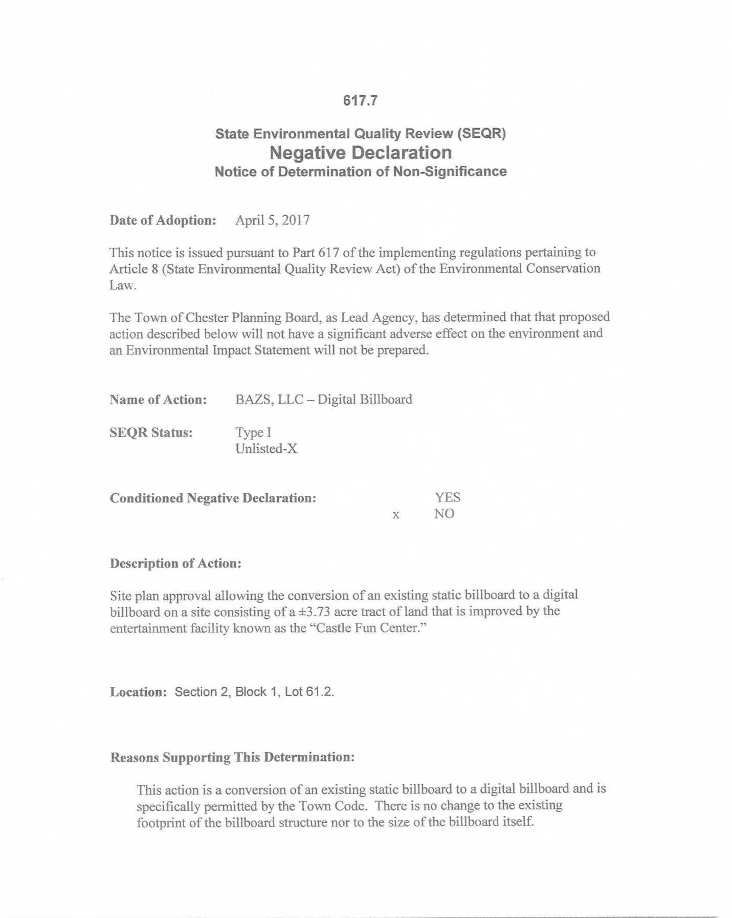
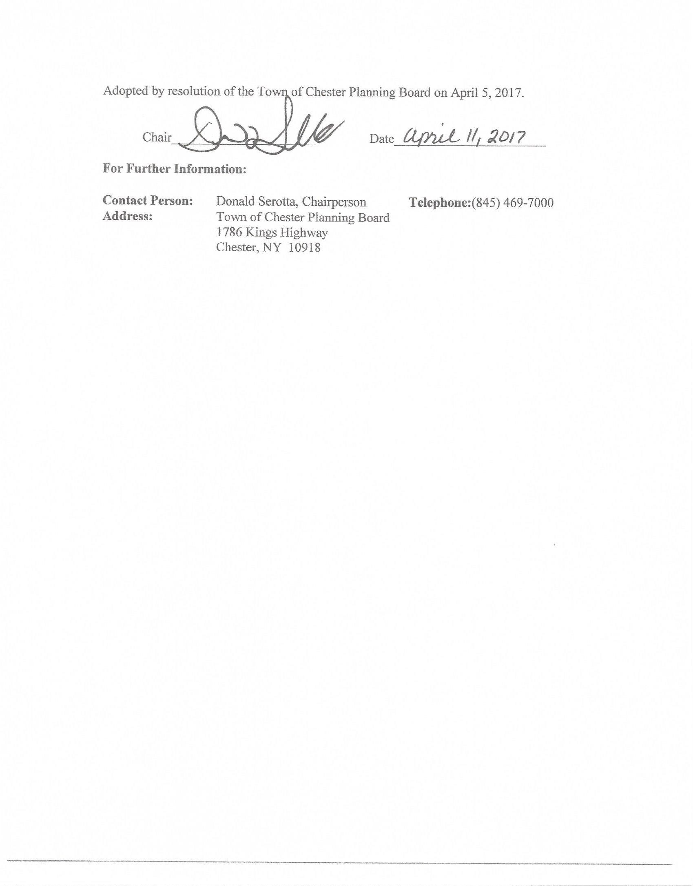
Motion made for to grant Final Approval by Dot. Second by Jackie. Motion carried 5-1. Barry opposed.
Durma Sub 2-Resolution
Bill Durma is here to settle family estate. Go approval from county to accept the size of the maps his engineer prints.
Dave Donovan drew up a resolution. Under conditions, this lot is not being approved as a building lot. Not paying parkland fees until such time he comes in to get a building permit. He would need to return to the planning board.
Al Fusco need to do perc test. And stamped and sealed plans. Resolution was perfect that counsel had done.
Dave spoke to Mr. Noviello beforehand, dedication of the area for future road widening purposes we will square away getting it all signed and file with the map.
Motion to grant a Negative Declaration made by Barry. Second by Steve. Motion carried 6-0.

Motion to grant Conditional Final Approval made by Jackie. Second by Barry. Motion carried 6-0.
Sage Outdoor-Site Plan Review
Doug Barthel looking to rebuild the existing billboards along Greycourt Road.
None of the faces are going to be digital. All are static faces.
Would like to rebuild with monopole and just update everything. Could rebuild with wood without coming in front of the board they just aren’t attractive. All are going to be 14X48 so they are uniform.
Al Fusco Letter:
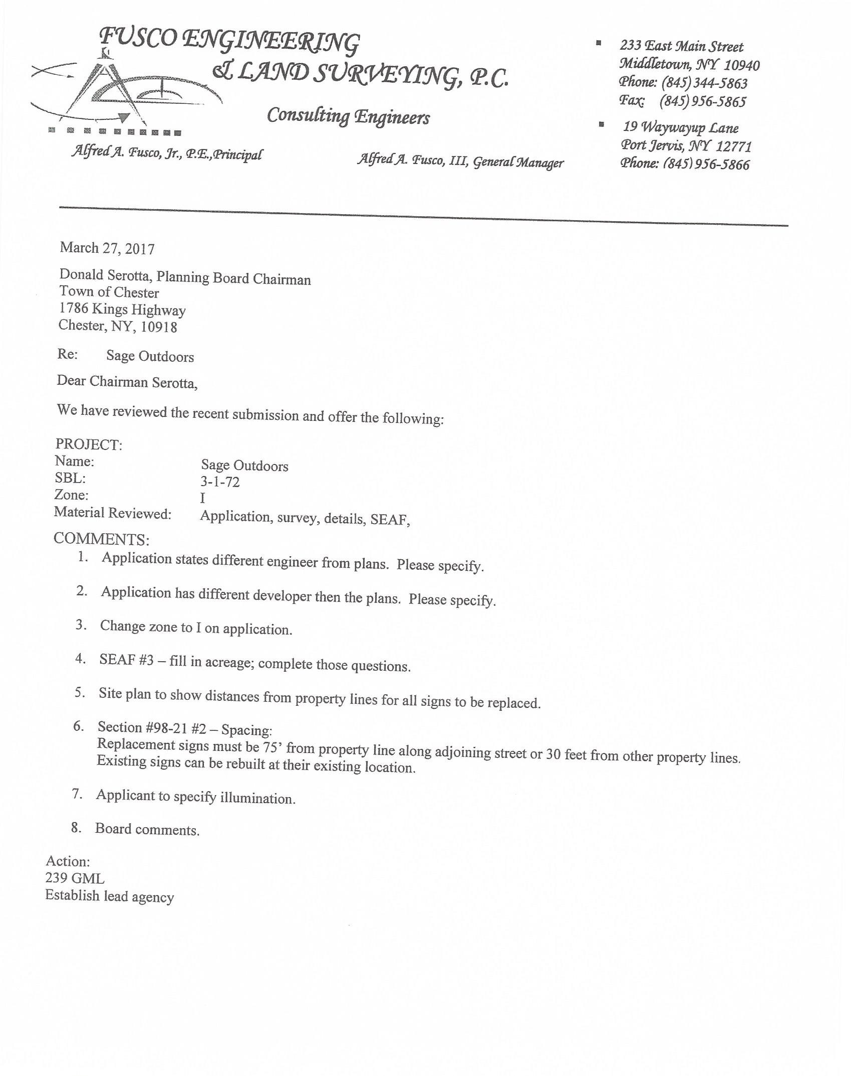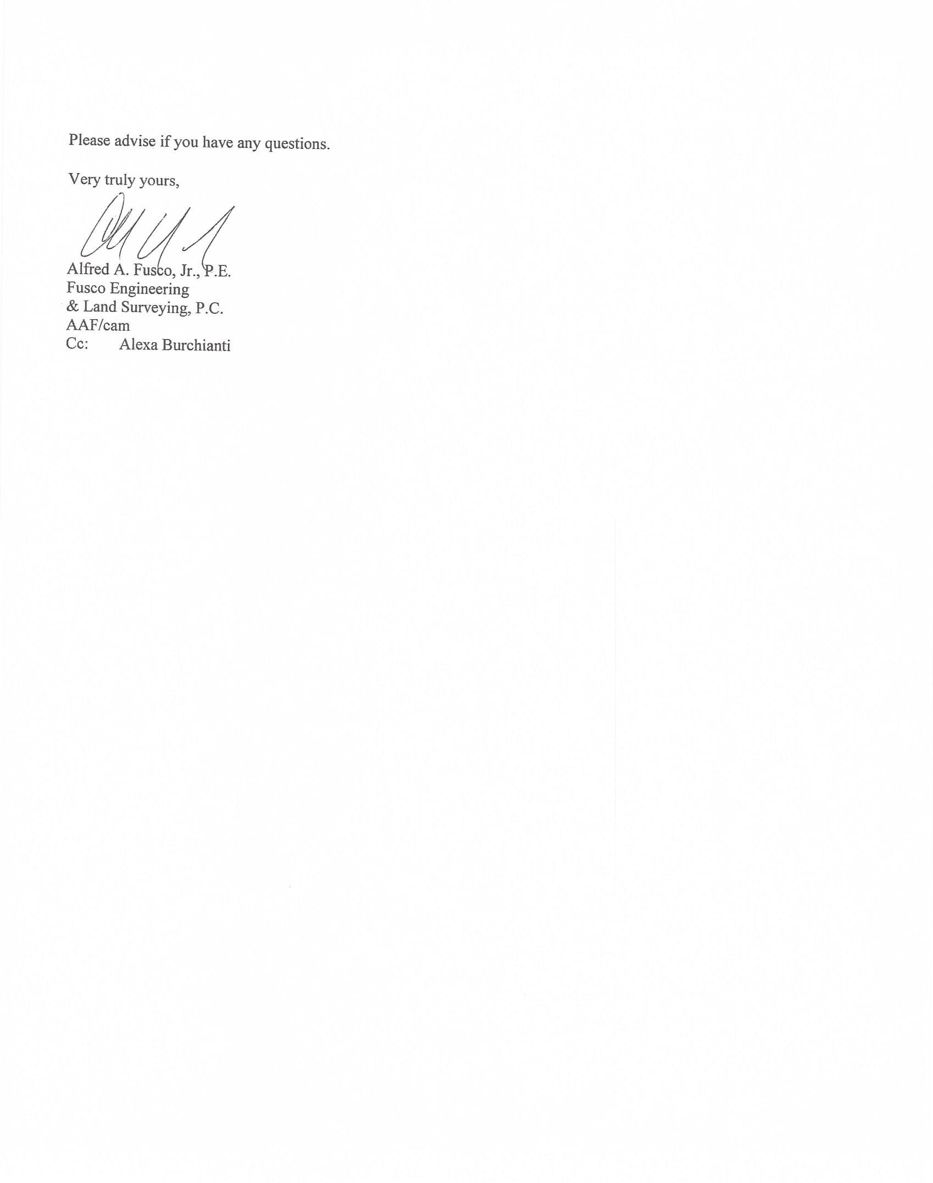
Show distances on the map. According to the code they can be rebuilt and replaced in the same location.
Poll Board for comments:
Barry: #7 on Al’s letter. Illumination? Doug: I send that in to Al, it’s a low dispersion led lights angled upward.
Need to send 239 referral to OCDP
Motion to set public hearing on May 3, 2017 @ 7pm. Motion made by Dot. Second by Barry. Motion carried 6-0
Legal notice and mailing list you will get from Alexa.
Hudson Solar-Work Session
Jeff Irish and Chris Patak from Hudson Solar. Proposing to do a small solar array on the Orange County Citizens Foundation property located at 23-26 White Oak Dr. the site is a 54 acre parcel in the AR3 zone. The whole array including the fencing should be approximately 1.5 acres. 300 kilowatt facility. Much smaller than the other solar farms. Easier to interconnect with Orange and Rockland. Minimal impact on the view shed in the community.
They are 110’ away from the wetlands. Wetlands buffer is 100 feet. Its 286 feet from the nearest home to the southeast and there are woods there.
All setback requirements are met. Its low height, at the highest point is 8ft at the highest angled peak and 5ft as the average height with 2ft from the ground.
Posts are pressed straight into the ground so as to not have ground disturbance. The only disturbance would be the trenching to lay the conduit which would be inside the fence perimeter. AC power would come out the southwest corner of the array and is about 65ft of buried ac transmission to the transformer and the Orange & Rockland meter and pre-existing Orange & Rockland pole.
The disturbed area is very small, it’s only about.065 acres for the entire system.
To comply with the national electrical code the entire system would have to be fenced. Picture of the fence was submitted. (Agricultural fence) wood posts with agricultural wire fence 4” steel squares with 4x2 squares closer to the ground. Low visibility. Definitely not a chain link fence or anything that might be a little more industrial looking.
This is a net metered site with benefits going to the Citizens foundation. It is a community distributed system. A portion of the output will go to the foundation to offset or eliminate their bills providing them with a cost reduction and a payment to lease the land. The modules will be sold to local residents. A minimum of 3 to comply with state regulations approx. 22 solar modules would be enough to offset the entire electric bill of the average residents in the area. And there will be enough solar modules here to cover the use of about 50 homes. If a customer moves out of the area as long as they have an Orange & Rockland account they will still receive the credits.
Poll Board for comments:
Barry: The town comprehensive plan we have to worry about the view sheds from kings highway and several other roads in the Town. This is right on Kings Highway.
Chris Patak presented pictures of the location with the existing growth along kings highway before everything started to fill in. Pointed out where all existing vegetation is on map.
They will go and put posts into the ground at the corners and put orange flags.
Chairman: You will need to file a regular site plan application, will need to do a 239 referral and have public hearing. Another thing to be ready to discuss is bonding. That is something that never got resolved with The Johnson solar farm. Purpose of bonding is for decommission so Nancy or the town doesn’t get stuck with the cost if the company goes out of business etc.
Dave: Just take a look at code 98-14 talks about fences and height requirements. If there is another code requirement that would trump this we would need to know what that is.
Will appear again on May 3rd.
John Jackson-Work Session
John Jackson is the owner of 9 Silver Tail. Would like to propose to move the dwelling from the approved location to further back on the property. Code 83-22(N) and being in the Ridge Overlay district he understands there are standards he needs to adhere to.
Going through 83-22(N) ….The new location would meet the required setbacks, not proposing to move the well or the septic system. The driveway opening is staying the same; the length of the driveway will just be longer. No changes in the site distances or drainage pattern changes. New location will not be near any state or federal wetlands or buffer. There is nothing environmentally sensitive on that lot.
Showed on the site map the current approved location of the house and drew on the map the location of the new proposed location. He staked out the new location. Also showed plans of the house he proposes to build. 100 % of this lot is visible for the first half mile of Pine Hill Road from the place that it comes into on Hamiltonian that entire length this entire lot is completely visible. No matter where you put the house you will see it for that first half mile. The lot has no trees, it’s a field. There are no trees to cut or deal with. There are about a dozen trees that have taken root by the rock wall that his wife would like to keep them.
There are 2 houses behind this lot that are completely visible in Warwick. Visual impact was done when the original sub-division was done. The visual impact is going to be the same. They are not cutting any trees.
No matter where this house is on this property you will be able to see it. It is a log home not a cabin. The color of the house is going to be a natural wood color and the roof an evergreen color. Will submit the actual colors to the board. Everything will blend in.
Non reflective glass will be used on the windows.
Need to submit a short EAF for the record.
Motion made to issue a Negative Declaration Ridge Overview and dwelling relocation. Motion made by Barry. Second by Jackie. Motion carried 6-0
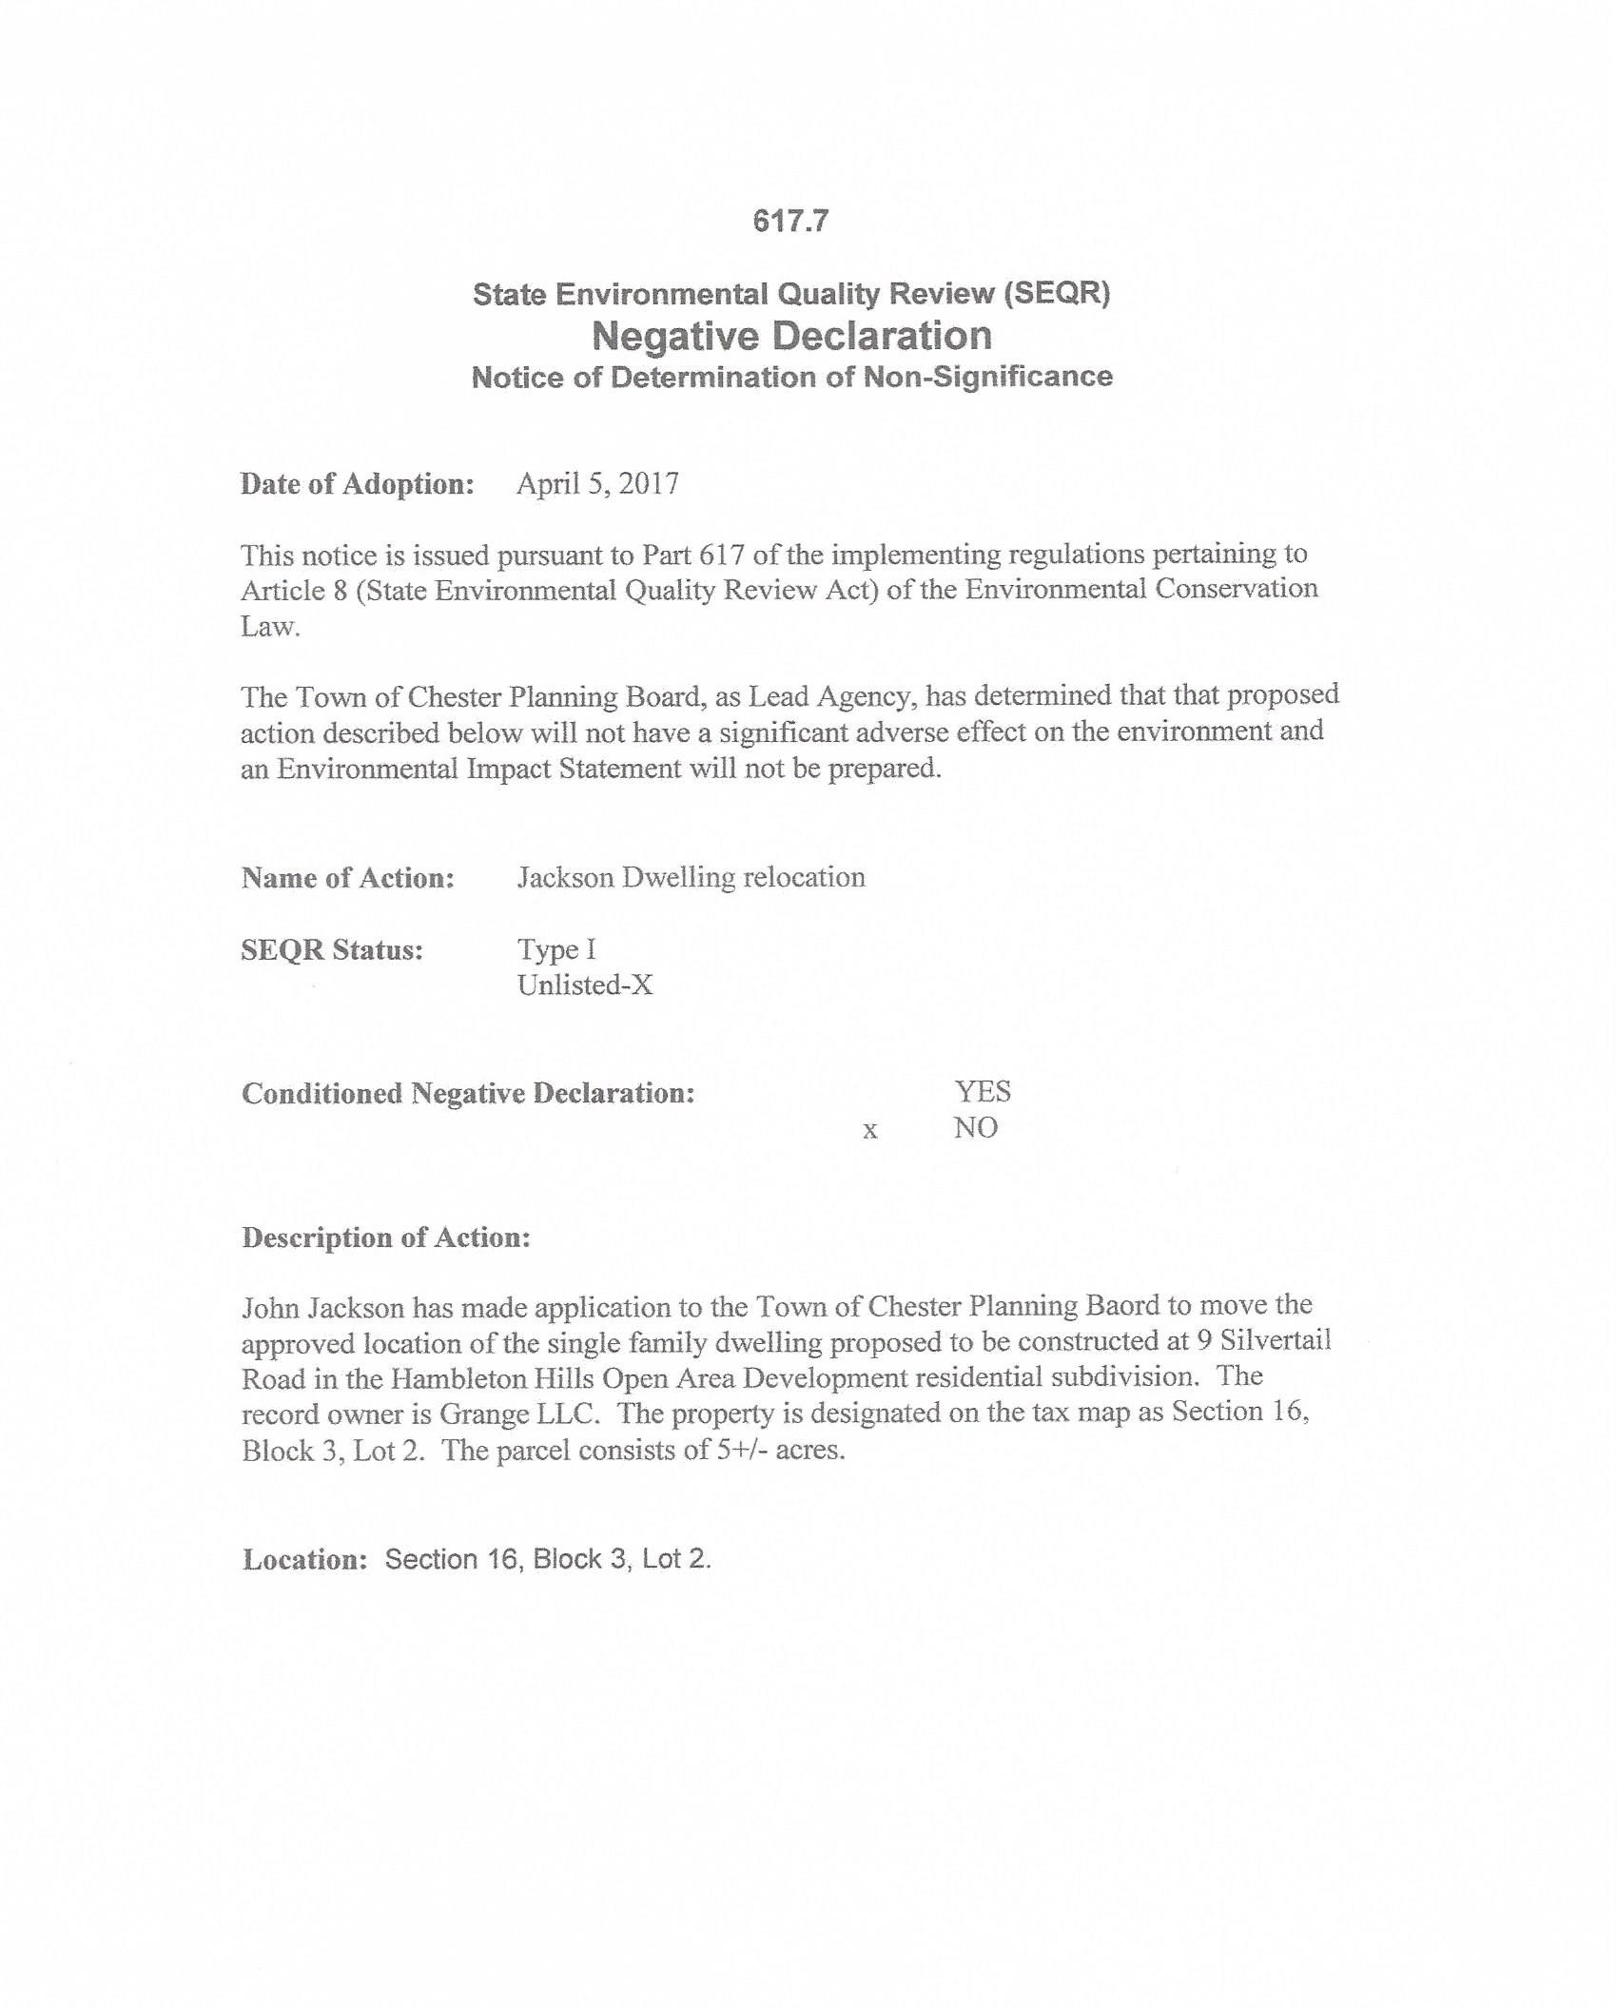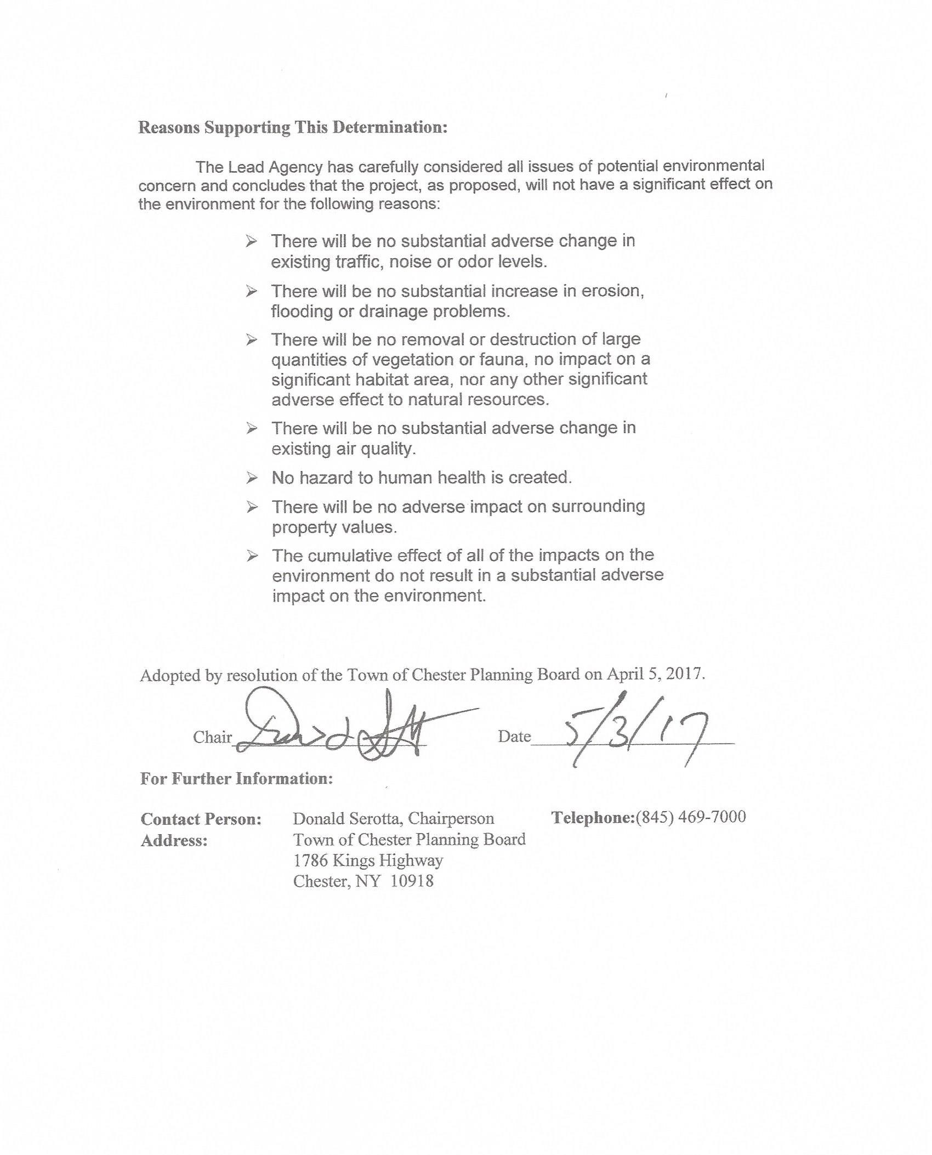
Motion made to grant Ridge overlay approval and house relocation approval subject to the colors that were discussed this evening. Motion made by Dot. Second by Barry. Motion carried 6-0.
Meeting adjourned.
Respectfully Submitted,

Alexa Burchianti
Planning Board Secretary

